AIRLINES USE CASE

NAME: TAMIZHINI R
REG NO : 25MCA0004

INTRODUCTION
The Airline Flight Operations Analysis project focuses on analyzing flight data to understand airline operations and identify useful operational insights. Airlines generate large amounts of data related to flights, airlines, routes, flight duration, and flight status. Analyzing this data can help organizations understand flight patterns, compare airline performance, monitor routes, and identify unusual or conflicting records.
In this project, the flight dataset is first cleaned and prepared using Python and Pandas. The cleaned data is then imported into Microsoft Power BI for analysis and visualization. An interactive dashboard is developed using KPI cards, charts, and slicers to present important flight-operation metrics in an easy-to-understand format.
The dashboard provides insights into airline trends, flight duration, route performance, flight status, and potential anomalies. The project demonstrates how data preprocessing and business intelligence tools can be combined to convert raw flight data into meaningful information that can support operational analysis and decision-making.

OBJECTIVES
- To analyze airline flight operations.
- To clean and prepare the flight dataset for analysis.
- To analyze flight duration across different airlines.
- To compare flight volumes and performance among airlines.
- To analyze route/source performance.
- To identify conflicting or anomalous flight records.
- To create an interactive Power BI dashboard.
- To provide KPI cards, charts, and slicers for easy analysis and interpretation

TOOLS & TECHNOLOGIES
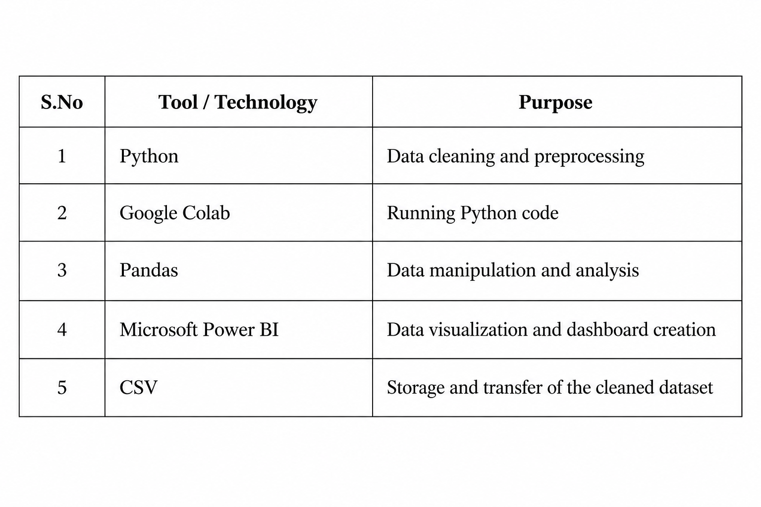
DATASET DESCRIPTION
DATASET OVERVIEW
The dataset used in this project contains flight-related information for analyzing airline operations. It includes details about airlines, flight routes, flight duration, flight IDs, and flight status. The dataset was cleaned and prepared before being used for visualization in Power BI.
DATASET SIZE
- Write the number of records based on your actual dataset. From your Power BI dashboard, you have 1,004 flight records (1,003 VALID + 1 CONFLICT).
- The dataset contains 1,004 flight records used for the analysis.
DATA CLEANING & PREPROCESSING (SAMPLE SCREENSHOT)
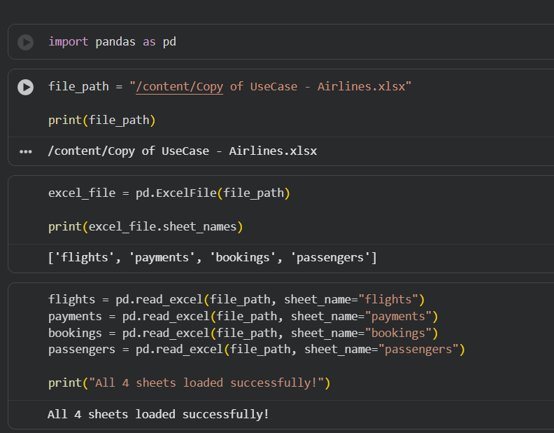
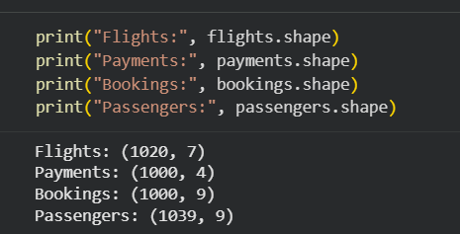
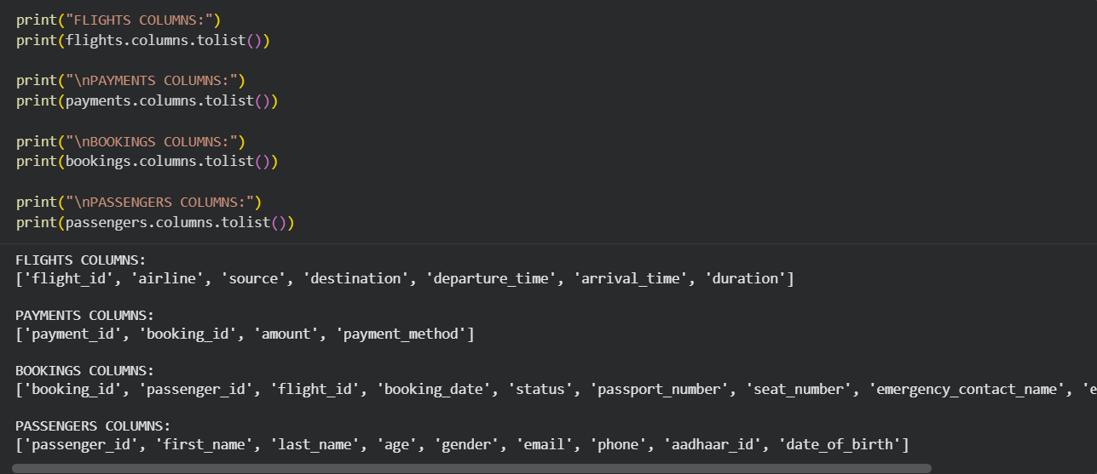
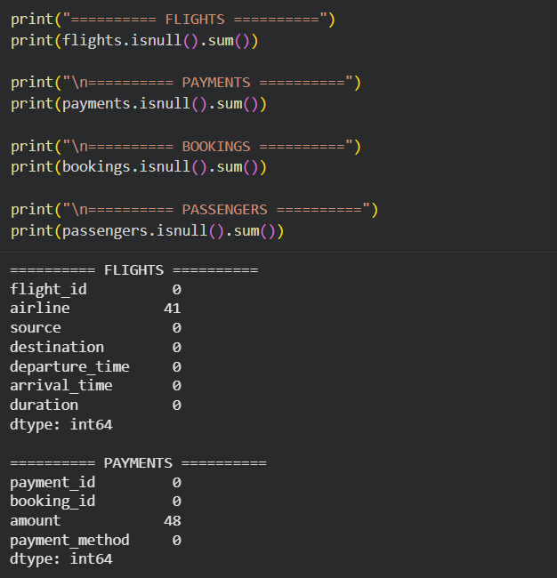
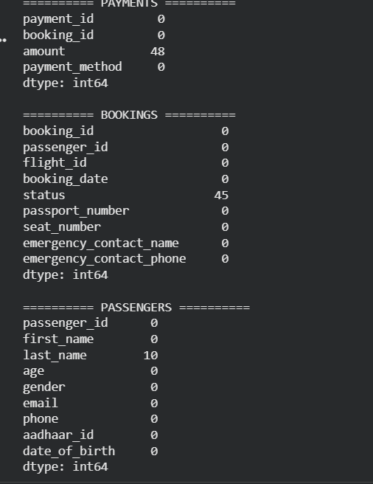

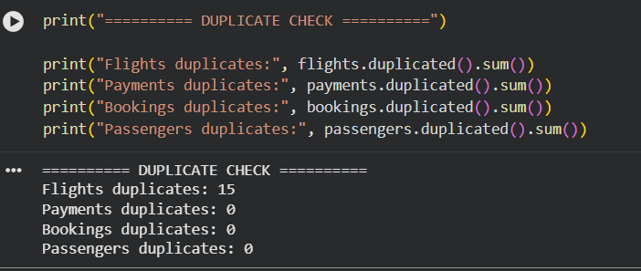

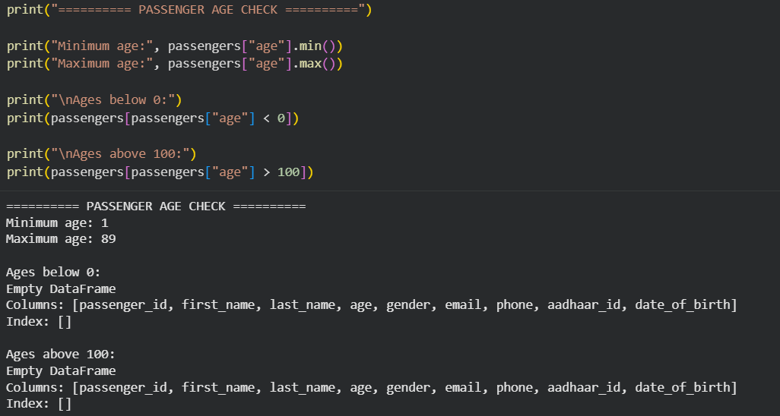
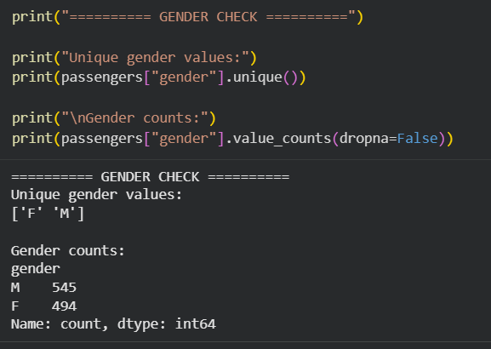
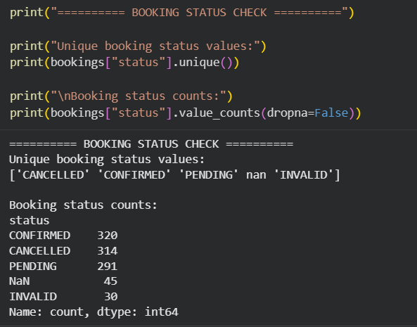
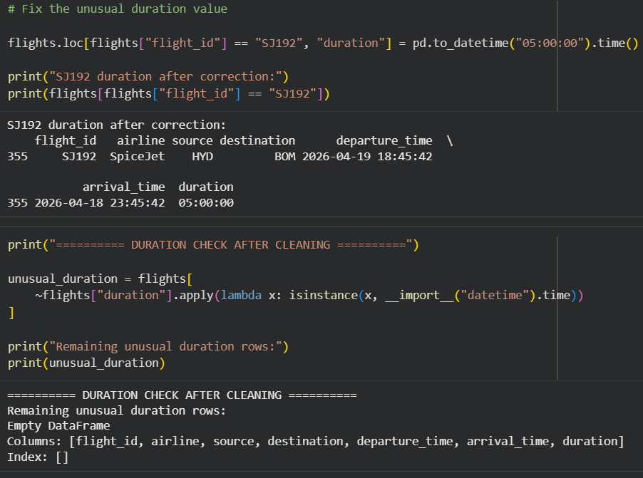
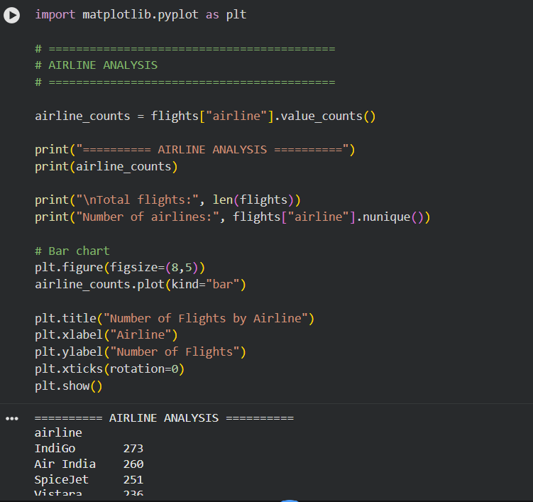
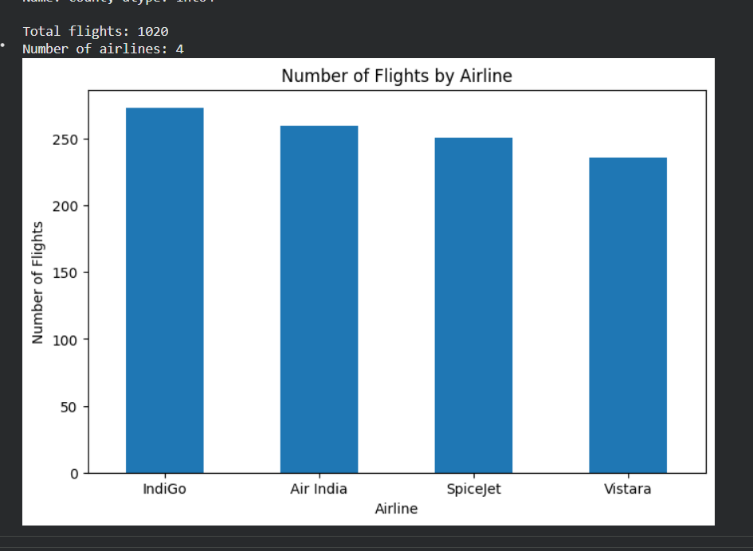

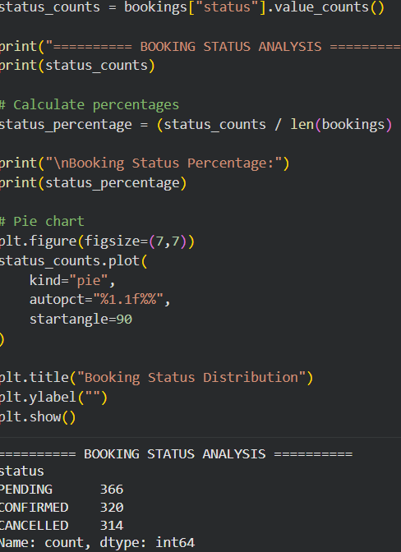
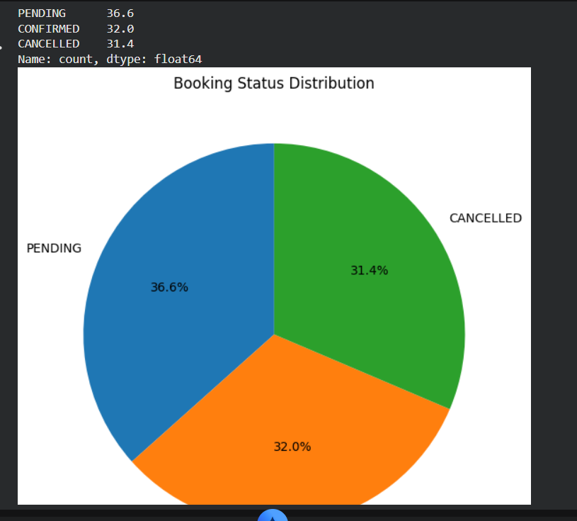

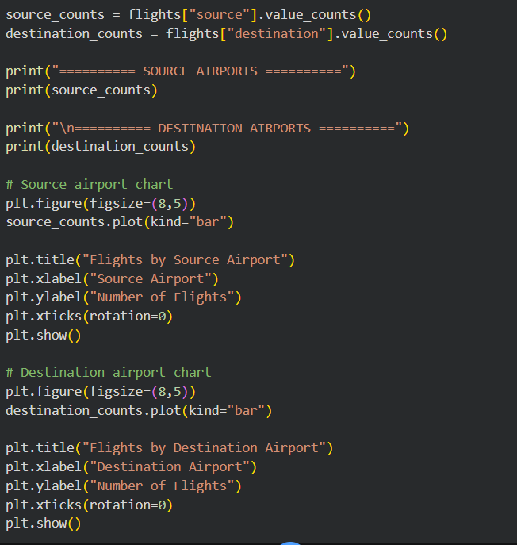
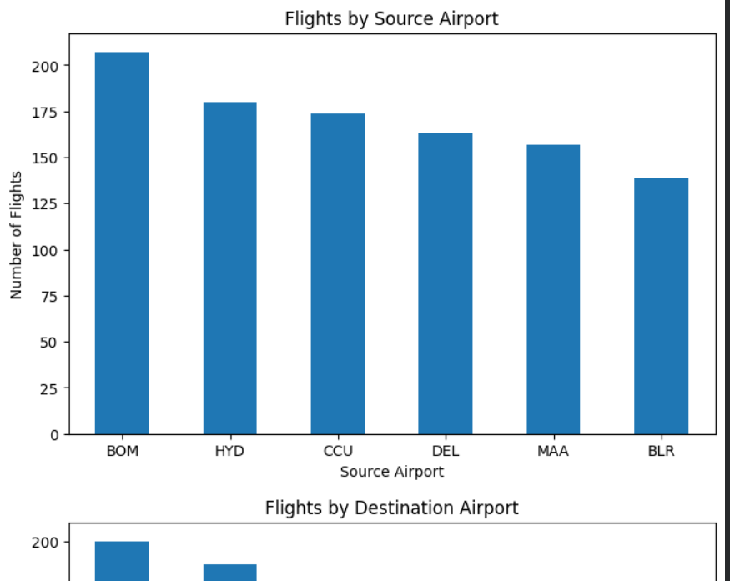

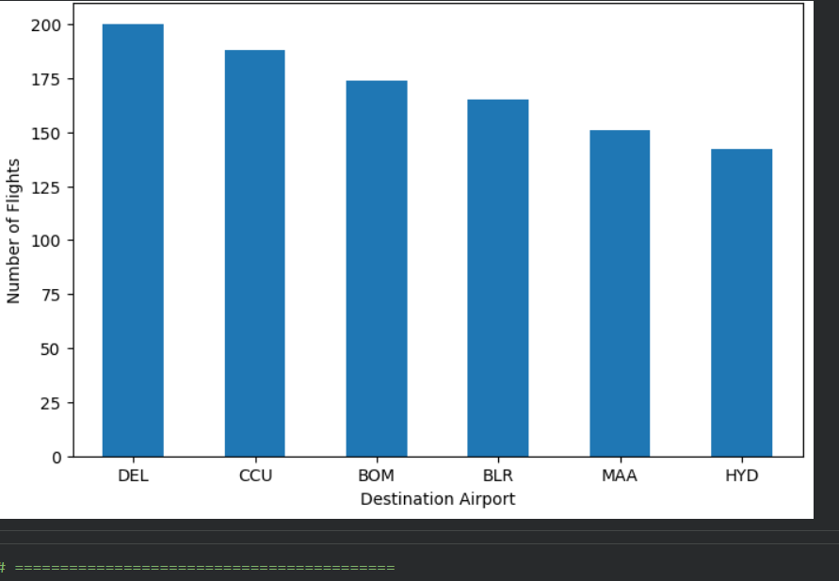

Power BI Dashboard

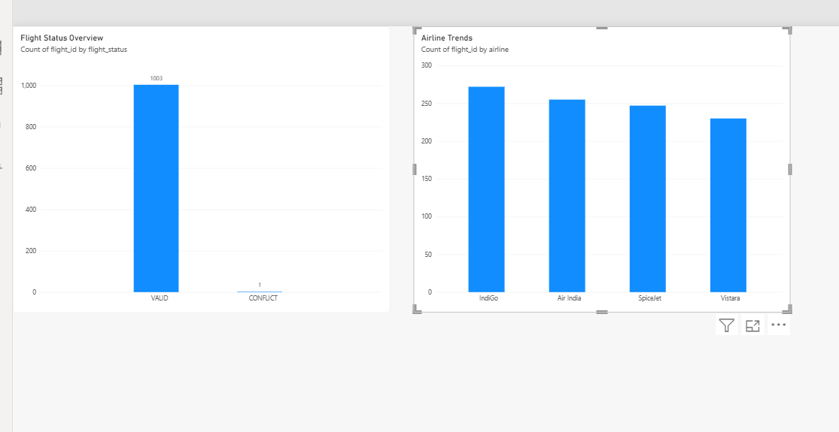
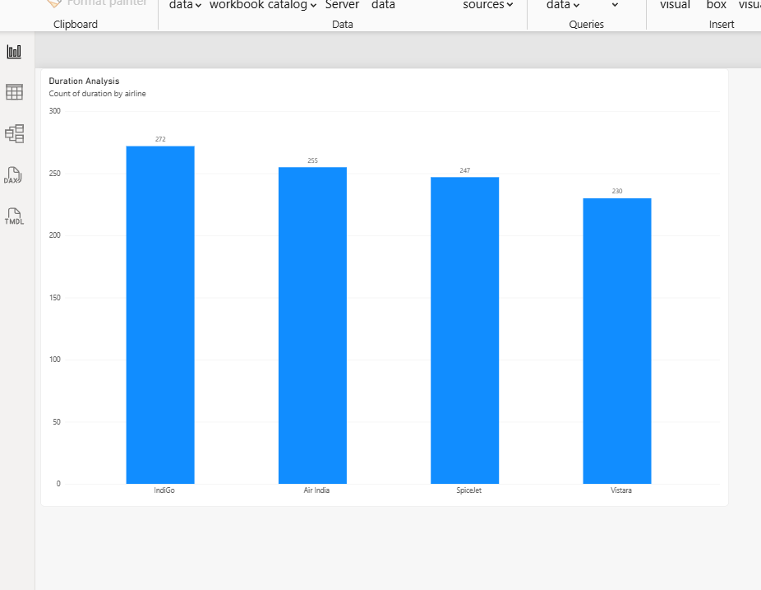

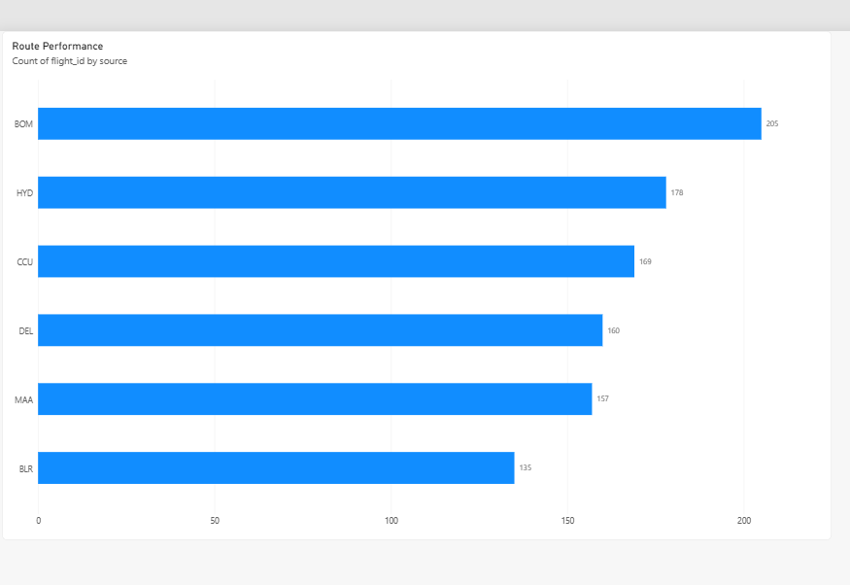
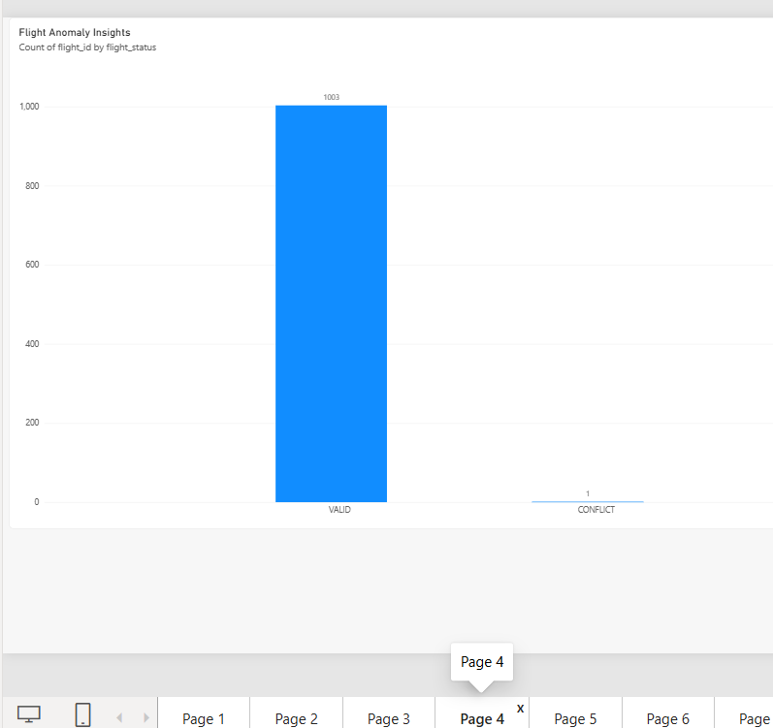

KPI CARD VISUALS
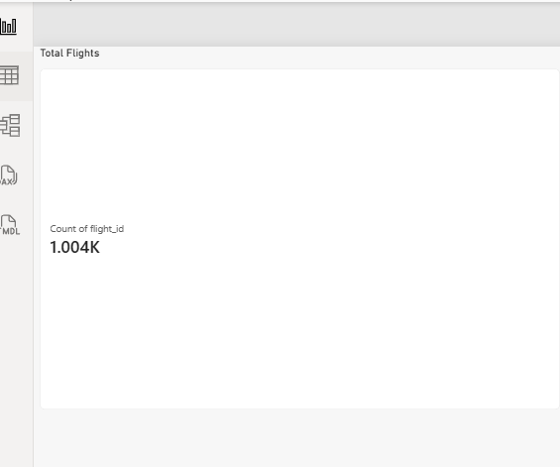
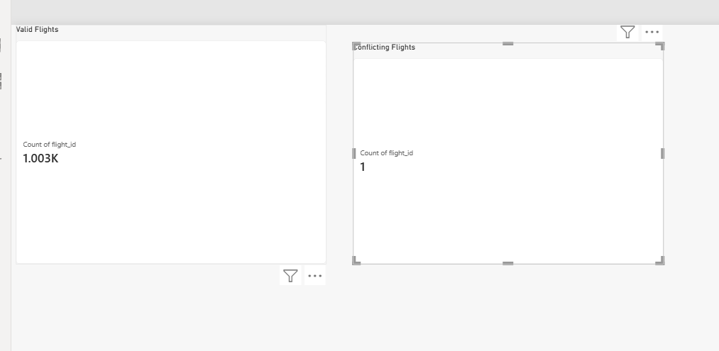

SLICER
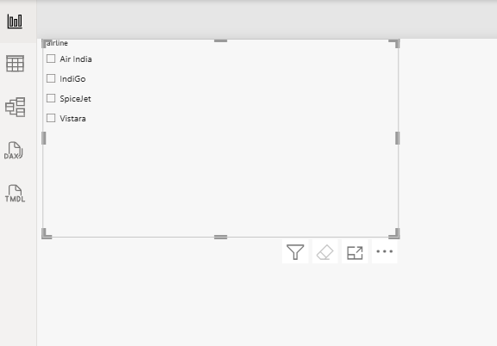

CLEANED DATASET
https://drive.google.com/drive/folders/1XEpD_ai6CjLVDPHIs6iy1raLBgMv42y-
CONCLUSION
This project successfully analyzed airline flight data using Python and Power BI.
The data was cleaned and transformed to identify meaningful flight operations insights.
An interactive dashboard was created with charts, KPI cards, and slicers for easy analysis.
The dashboard helps understand airline trends, flight duration, route performance, and flight anomalies.

